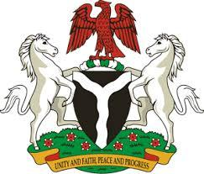

Please check against delivery

HUMAN RIGHTS COUNCIL
43RD SESSION OF THE UPR WORKING GROUP
STATEMENT
BY THE
FEDERAL REPUBLIC OF NIGERIA
ON THE
REVIEW OF FRANCE
1ST MAY, 2023

Mr. President,
Nigeria warmly welcomes the delegation of France to the presentation of its National Report and commends the Government for its unwavering commitment to its international human rights obligations and continued cooperation with human rights mechanisms.
2. We commend the commitment of the French Government on the efforts demonstrated in formulating a new National Plan to Combat Racism, Antisemitism and Discrimination on Grounds of Origin, covering period 2023 - 2026. We further welcome the incorporation of measures to combat racial discrimination, particularly, in access to employment, during one’s professional career and access to housing. In addition, Nigeria takes positive note of the law enacted to combat hateful content on the internet.
3. In the spirit of constructive dialogue, Nigeria wishes to recommend the following for consideration by the French Government:
- to intensify efforts to completely eliminate racism and racial discrimination;
- to mobilise sufficient funding and human resources to effectively combat all forms of trafficking; and
- take necessary steps facilitate and guarantee access to justice for all victims of trafficking.
4. In conclusion, we wish France a very successful review process.

I thank you Mr. President.

