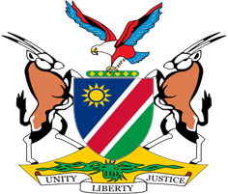

Statement by Mr. Jerry Mika, 41st session, UPR Israel, 09 May 2023

Time: 1 Minute and 20 seconds

- Thank you, Mr. President,

- Today we are reviewing the human rights record of Israel, a country that has for over seven decades violated the human rights, including the right to self-determination of the Palestinian People. These human rights violations continue unabated as Israel employs policies which are all aimed at prolonging the illegal occupation over the Palestinian territories.

- Given this injustice and the peremptory nature of the right to self-determination, Namibia makes the following three recommendations for implementation by Israel:

  - Dismantle the apartheid system and Israeli settlements which is aimed at prolonging the illegal occupation and denying the right to self-determination of the Palestinian People.

  - Recognize and implement the fundamental rights of Palestine Refugees and their descendants to return to their homes, and provide restitution, compensation and other effective remedies for loss of their land and property;

  - Revoke the designations against Palestinian human rights and humanitarian organizations as terrorist or unlawful organizations.

- In conclusion, we again call on all States, in accordance with their erga omnes obligations, to refrain from recognizing and supporting the illegal occupation, apartheid system and settlement activities of Israel in the Palestinian Territories.

- I thank you, Mr. President.

