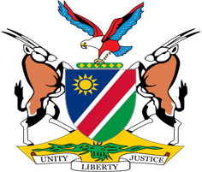

Statement by Mr. Jerry Mika, UPR of the United Arab Emirates, 08 May 2023

- Thank you, Mr. President,

- Namibia warmly welcomes the esteemed delegation from the United Arab Emirates and thank them for their continued cooperation with mechanisms of the Human Rights Council, including the Universal Periodic Review.

- We have taken note with appreciation of the progress made by the United Arab Emirates in the area of human rights promotion and protection since its last review in 2018. Namibia, amongst others, commends the United Arab Emirates for implementing programmes that seek to enhance the quality of live and protect the rights of older persons.

- In the spirit of constructive dialogue, Namibia makes the following recommendations for consideration by United Arab Emirates:

  - Ratify the International Covenant on Civil and Political Rights;
  - Ratify the International Covenant on Economic, Social and Cultural Rights;
  - Ratify the Optional Protocol to the Convention on the Elimination of All Forms of Discrimination against Women.

- We wish the delegation of the United Arab Emirates a successful review.

- I thank you.

