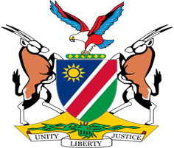

Statement by Jerry Mika, Deputy Permanent Representative, UPR of Montenegro, 08 May 2023

- Thank you, Mr. President,

- Namibia welcomes the esteemed delegation from the Republic of Montenegro to the fourth cycle Universal Periodic Review. We thank the Government for its commitment to further advance respect for and protect human rights in Montenegro.

- Namibia has take note with appreciation of the legislative, administrative, institutional and other measures taken by Montenegro since the last review. We amongst other applaud Montenegro for proiritizing the provision of human rights education and training to employees in the public sector. We also pleased to note that Montenegro, in accordance with her international human rights obligations, continues to pursue efforts aimed at combatting domestic voilence and voilence against women and children.

- There, however, remains room for improvement, and Namibia offers the following recommendations for consideration by Montenegro:

  - Take effective measures to prevent, combat, and punish racist hate speech and crimes.

  - Stregthen measures to combat all forms of slavery, including by adopting a more comprehensive strategy to prevent, suppress and punish trafficking in persons.

- We wish the delegation of Montenegro a successful review.

- Thank you.

