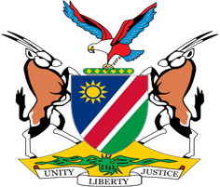

Statement by Jerry Mika, Deputy Permanent Representative, UPR of the Grand Duchy of Luxembourg, 04 May 2023

- Thank you, Mr. President,

- Namibia welcomes this opportunity to have a constructive dialogue with the esteemed delegation from the Grand Duchy of Luxembourg on the measures taken during the period under review to promote and protect the human rights of all persons in Luxembourg.

- Namibia, amongst others, applauds Luxembourg for adopting a National Action Plan on the implementation of the Convention on the Rights of Persons with Disabilities. Equally commendable is the human rights education Luxembourg is providing to its diplomatic corps, teachers, and other professionals in the public service.

- While noting with appreciation the progress made, Namibia offers the following recommendations for consideration by Luxembourg:

  - Take effective measures to combat racism and all forms of discrimination against people of African Descent.

  - Strengthen measures to prevent illicit financial flows from third countries that are being deposited in financial institutions in Luxembourg.

- We wish the delegation of Luxembourg a successful review.

- I thank you Mr. President.

