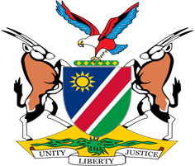

Statement by Jerry Mika, Deputy Permanent Representative, UPR of Burundi, 04 May 2023

- Thank you, Mr. President,

- Namibia warmly welcomes the distinguished delegation of Burundi, and we thank them for their continued participation in the UPR process which is testamony of the Government's commitment to further improve human rights for all persons in Burundi.

- Namibia, has taken note, with appreciation of the positive human rights developments in Burundi since its last review. These include among others the measures taken promote and protect the rights of women such as adoption of policies to combat gender based violence and the appointment of gender focal points in all police stations, courts and tribunals in Burundi.

- There, However, remains room for improvement, and in the spirit of constructive dialogue, Namibia offers the following two recommendations for consideration by Burundi:

  - Take measures to further strengthen the formal and material independence of the National Human Rights Commission in accordance with the Paris Principles;

  - Ratify the Second Optional Protocol to the International Covenant on Civil and Political Rights, aiming at the abolition of the death penalty.

- We wish the delegation of Burundi a successful review.

- I thank you Mr. President.

