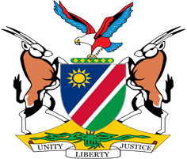

Statement by Jerry Mika, Deputy Permanent Representative, UPR of Mali, 02 May 2023

- Thank you, Mr. President,

- Namibia warmly welcomes the esteemed delegation of Mali, and we thank them for submitting their national report on the progress made as well as the challenges encountered in implementing the recommendations Mali accepted at its third cycle universal periodic review in 2018.

- Namibia, amongst other things, commends Mali for its commitment to strengthen the capacity of the National Human Rights Commission. We urge the Government to pursue further efforts aimed at ensuring that the National Human Rights Commission is adequately resourced to carry out its functions.

- We have also taken note with appreciation of the ongoing efforts by Mali to protect the rights of women, and in this regard applaud the appointment of gender focal points in all courts.

- There, However, remains room for improvement, and in the spirit of constructive dialogue, Namibia offers the following two recommendations for consideration by Mali:

  - Ratify the Second Optional Protocol to the International Covenant on Civil and Political Rights, aiming at the abolition of the death penalty.

  - Take effective measures to promote integrity and accountability in the public administration, including by adopting legislation to prevent, detect, punish, and eradicate corruption.

- We wish the delegation of Mali a successful review.

- I thank you Mr. President.

