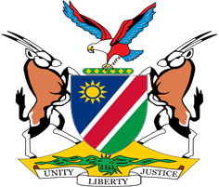

Statement by Jerry Mika, Deputy Permanent Representative, UPR of the Kingdom of Tonga, 01 May 2023

- Thank you, Mr. President,
- Namibia welcomes the distinguished delegation from the Government of the Kingdom of Tonga, and we thank them for their continued commitment to the UPR process.
- Namibia has taken note with great appreciation of the progress made by Tonga in the area of human rights promotion and protection, this notwithstanding the significant challenges brought about by the negative effects of climate change. We, amongst others, commend the Government of Tonga for providing free medical and dental care to all persons in Tonga.
- Namibia offers the following two recommendations for consideration by Tonga:
  - Ratify all core international human rights treaties, including the International Covenant on Civil and Political Rights.
  - Strengthen legislative and institutional frameworks to prevent, suppress, and punish all forms of slavery, including trafficking in persons.
- We wish the Delegation of Tonga a successful review.
- I thank you Mr. President.

