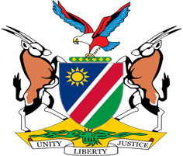

Statement by Jerry Mika, Deputy Permanent Representative, UPR of France, 01 May 2023

- Thank you, Mr. President,

- Namibia warmly welcomes the esteemed delegation of Franc and thank them for submitting a comprehensive national report outlining the progress made in promoting and protecting human rights in France since its last review.

- The measures taken by France to address social inequalities in health are among the numerous positive human rights impact measures that have found our appreciation. We also pleased to note that France continues to take active steps to protect the rights of women and to advance professional equality between men and women.

- In the spirit of constructive dialogue, Namibia offers the following two recommendations for consideration by France:

  - Take appropriate measures to ensure that French Nationals and corporations do not unlawfully participate in the taking of Western Sahara’s resources;

  - Adopt legislation clearly defining and prohibiting racial and ethnic profiling by law enforcement officials.

- We wish the delegation of France a successful review.

- I thank you Mr. President.

