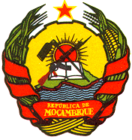
STATEMENT BY HE MR AMADEU DA CONCEICAO, AMBASSADOR AND PERMANENT REPRESENTATIVE OF THE REPUBLIC OF MOZAMBIQUE TO THE UNITED NATIONS OFFICE AND OTHER INTERNATIONAL ORGANIZATIONS IN GENEVA TO THE 43rd SESSION OF THE UPR WORKING GROUP ON LUXEMBOURG

GENEVA, MAY 4, 2023

Mr. President,

Mozambique warmly welcomes and thanks the distinguished delegation of Luxembourg for the submission of their country’s comprehensive report on the UPR.

We appreciate the progress made by Luxembourg in the field of human rights since the previous national report of UPR, in particular, we appreciate the efforts made, that culminated in the signing of international and regional instruments in the field of human rights.

In a constructive spirit, we recommend the Luxembourg the following:

- To continue strengthening its legal framework and general policies for combating racism and racial discrimination

Mozambique wishes the Luxembourg every success in the present UPR review.

Thank you, Mr. President

