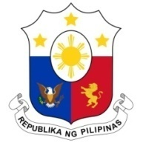
PHILIPPINES

Human Rights Council
43rd session of the Working Group on the Universal Periodic Review

Universal Periodic Review of FRANCE
01 May 2023, Room XX

Speaking Time: 55 seconds

Thank you, Mr. President,

The Philippines welcomes France’s efforts to strengthen policy frameworks on human rights, including its support for the global compacts for migration and refugees.

While recognizing sustained commitment to combat all forms of discrimination, the Philippines notes the concern of relevant UN bodies about persistent discriminatory practices against minorities and regressive policies affecting migrants, refugees, and asylum-seekers. The Philippines thus recommends that France:

- Intensify efforts against racial profiling, hate speech, hate crimes, and police abuses by strictly enforcing its new National Plan;
- Fully uphold the principle of non-refoulement and end pushback policies against refugees and asylum-seekers, especially women and children; and
- End the detention of children by adopting non-custodial mechanisms.

Lastly, the Philippines recommends more effective measures to expand access to education of children in its overseas territories.

Thank you. END

2023-2026 National Plan to Combat Racism, Anti-Semitism and Discrimination Based on Origin

