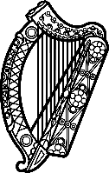

Statement of Ireland
43rd session of the UPR Working Group

Review of the United Arab Emirates

8 May 2023

Ireland welcomes the delegation of the United Arab Emirates and thanks it for its presentation today.
Ireland acknowledges the UAE’s efforts to advance human rights and notes progress made since the last UPR cycle.
We welcome the opening of the interfaith ‘Abrahamic Family House’ this year and note the UAE’s ongoing efforts to create a tolerant and religiously diverse society.
Ireland regrets the continued impact of the law on Combating Terrorism Offences on civil liberties, including on the right to privacy and freedoms of opinion and expression, peaceful assembly and association.

Ireland recommends that the United Arab Emirates:
- Ratify the International Covenant on Civil and Political Rights.
- Abolish the death penalty in law and in practice, including by establishing a formal moratorium and commuting existing death sentences.

We wish the United Arab Emirates every success in this UPR cycle. Thank you.

