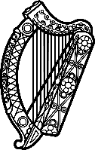

Statement of Ireland
43rd session of the UPR Working Group

Review of FRANCE

Monday, 1 May 2023

Ireland welcomes the delegation of France and thanks it for its presentation.

Ireland welcomes France’s ratification of ILO Convention 190. We also note the recently published National Plan Combating Racism, Antisemitism and Discrimination Linked to Origin and encourage further measures to combat racism and discrimination.

We are concerned by insufficiency of services provided to women victims of violence as well as issues facing individuals across French territories in accessing affordable and safe water and sanitation.

Ireland recommends France:
- Review the legislative framework and procedures with a view to enhancing access to justice for victims of domestic violence.
- Ensure water and sanitation are available, accessible, affordable and of adequate quality for all persons across the territory of the French Republic.

We wish France every success in this UPR cycle.

