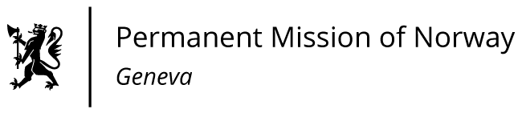

STATEMENT

43rd UPR Session of the Human Rights Council

on the human rights situation in Burundi,

as delivered by Ms Sigrun Stigen HOLTER

First Secretary, Human Rights.

Check against delivery
4 May 2023

President,
Norway is deeply concerned about continued human rights violations in Burundi, including impunity for extrajudicial killings, forced disappearances, torture and sexual violence.
Norway recommends that Burundi:
1) ends reprisals against human rights defenders, journalists and members of the opposition and civil society;
2) ensures that crimes against human rights defenders, journalists, LGBTIQ people, indigenous peoples, and members of the opposition and civil society, are properly investigated, and that those responsible are held accountable;
3) disarms and demobilises the Imbonerakure and takes concrete steps to reform the police and security forces, as well as the National Intelligence Service;

4) cooperates with the Special Rapporteur on the human rights situation in Burundi by allowing full and unhindered access to the country and by providing all information needed to fulfil its mandate;

5) takes concrete and effective measures to prevent gender-based violence, and ensures that allegations of violence against women, including domestic violence, are thoroughly investigated and perpetrators of such acts brought to justice.
I Thank you.

