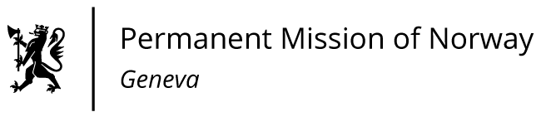

STATEMENT

43rd UPR Session of the Human Rights Council

on the human rights situation in United Arab Emirates,

as delivered by Ambassador Tine Mørch Smith,

Permanent Representative of Norway in Geneva.

Check against delivery
8 May 2023

Vice President,

Norway notes the positive steps taken since the last review, including the introduction of the new Labour Law promoting gender equality and non-discrimination, and the establishment of a National Human Rights Institution.

Norway recommends that UAE :

1) continues to adopt measures to strengthen and improve the rights and protection of migrant workers, including domestic workers, as part of the implementation of the Labour Law and Domestic Labour Law;

2) takes steps to ensure the full exercise of the rights to freedom of expression and association and a safe environment conducive to the work of human rights defenders and civil society organisations;

3) strengthens cooperation with UN human rights mechanisms by permitting visits by the Special Procedures ;

4) withdraws its reservations to the Convention on the Elimination of All Forms of Discrimination against Women;

5) establishes a moratorium on the use of the death penalty as a step towards its abolition.

I Thank you.

