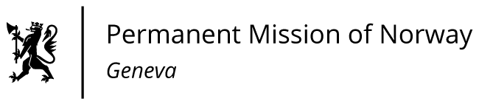

STATEMENT

43rd UPR Session of the Human Rights Council

on the human rights situation in Israel,

as delivered by Ambassador Tine Mørch Smith,

Permanent Representative of Norway in Geneva.

Antall ord: 158
ISRAEL
Tuesday 09 May 2023, 09:00 – 12:30
Speaking time: 01 minute and 20 seconds

Norway no. 13 av 95

Check against delivery
9 May 2023

Thank you Mr. President,
President,
Norway is following the debate in Israel on the judicial reforms closely.
Norway recommends that Israel:
1) Protects the principle of separation of powers and the independence of the courts, and respects the human rights, including social and political rights, of all its citizens, including women, children, and LGBTIQ people.
2) Ensures freedom of religion and belief, including for ethnic and religious minorities;
3) Ensures that Israeli and Palestinian civil society actors, including human rights defenders, can carry out their work unhindered;
4) Protect prisoners’ rights, minimize the use of administrative detention of minors and bring such practice in line with international human rights standards.
5) Protects the rights of Palestinian civilians living under occupation in accordance with international humanitarian and human rights law;
6) Ratifies the Second Optional Protocol to the International Covenant on Civil and Political Rights, aiming at the abolition of the death penalty.
I Thank you.

