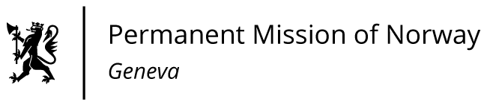

STATEMENT

43rd UPR Session of the Human Rights Council

on the human rights situation in Serbia,

as delivered by Ms Jannicke Graatrud,

Minister, Deputy Permanent Representative.

Check against delivery
10 May 2023

Vice President,

Let me first of all reiterate that Norway stands with the people of Serbia after the recent tragic mass shootings. Our hearts go out to all those affected.

Norway commends Serbia for the progress made since the last UPR hearing.

Despite positive trends, there are still concerns regarding harassment and threats against journalists; distortion of political diversity in media; violence against women, LGBTIQ persons and detainees; and the lack of effective prosecution and dissuasive penalties.

Norway recommends that Serbia:

1) Take concrete steps to improve the independence and efficiency of the prosecution and the judiciary according to the Judicial Development Strategy.

2) Uphold the right to freedom of expression and combat intimidation of the media and civil society by fully implementing the Media Strategy.

3) Implement a comprehensive policy to combat discrimination and violence against women, as well as based on sexual orientation and gender identity.

4) Address all forms of ill-treatment of detainees, including the recommendations made by the Council of Europe’s Committee on the Prevention of Torture.

I Thank you.

