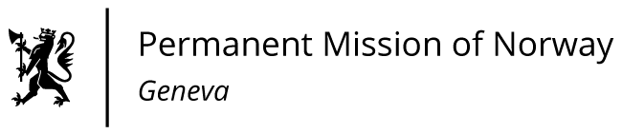

STATEMENT

43rd UPR Session of the Human Rights Council

on the human rights situation in Mali,

as delivered by Ms Anniken ENERSEN

Minister Counsellor, Human Rights

Check against delivery
2 May 2023

President
Norway remains concerned about the human rights situation in Mali. Last year saw the highest number of civilian deaths in a decade. Human rights violations and abuses are not being investigated effectively; freedom of expression is under severe pressure. Grave violations against children are on the rise.
Norway recommends that Mali:
1) ensures that allegations of human rights violations and abuses are investigated and prosecuted effectively, and allows MINUSMA full access to ensure independent and impartial investigations;
2) upholds the rights to freedom of association, peaceful assembly and expression and ensures the safety of journalists, human rights defenders, and activists;
3) takes concrete steps to combat female genital mutilation and adopts criminal legislation explicitly prohibiting it;
4) ensures compliance with the conclusions agreed in the Working Group for Children and Armed Conflict;

5) ensures that no individual is subject to forced labour and hereditary slavery, in accordance with ILO Forced Labour Convention No 29.

Thank you.

