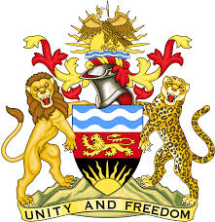
REPUBLIC OF MALAWI
MALAWI STATEMENT ON BURUNDI UNIVERSAL PERIODIC REVIEW
4TH MAY 2023
Mr President,
Malawi welcomes the delegation of Burundi to this review and notes the progress made in the promotion and protection of human rights. This includes passing of human rights related legislation, the A status re-accreditation of the Human Rights Commission, strengthening mandates of the Ombudsman and the Truth and Reconciliation Commission.
We make the following recommendations:
- Continue with efforts to combat gender-based violence.
- Take all necessary measures to increase the representation of women in decision making bodies and state institutions.
- Continues with efforts to submit all outstanding reports to the UN Human Rights Treaty Bodies.
We wish Burundi all the best in this review.
Thank you

