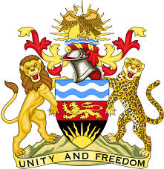
REPUBLIC OF MALAWI
MALAWI STATEMENT ON THE BAHAMAS UNIVERSAL PERIODIC REVIEW
3RD MAY 2023
Mr President,
Malawi welcomes the delegation of The Bahamas to this review and notes the progress made in the promotion and protection of human rights despite facing challenges caused by the impact of hurricane Dorian and the Covid pandemic.
We make the following recommendations:
- Continue with efforts to combat trafficking in persons.
- Take all necessary measures to promote equality for women and girls.
- Continues with efforts to submit all outstanding reports to the UN Human Rights Treaty Bodies.
We wish The Bahamas all the best in this review.
Thank you

