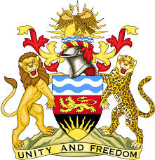
REPUBLIC OF MALAWI
MALAWI STATEMENT ON BOTSWANA UNIVERSAL PERIODIC REVIEW
3RD MAY 2023
Mr President,
Malawi welcomes the delegation of Botswana to this review and notes the progress made in the promotion and protection of human rights. This includes the establishment of the Office of the Ombudsman as an NHRI, acceding to the CRPD, and hosting various special procedures mandate holders.
We make the following recommendations:
- Continue with efforts to increase the representation of women in senior positions of the public service.
- Consider ratification of outstanding international human rights treaties, in line with the country’s national priorities.
- Conclude the process of enacting the Anti-Human Trafficking (Amendment) Bill 2023.
We wish Botswana all the best in this review.
Thank you

