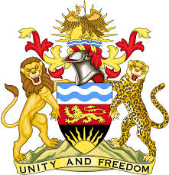
REPUBLIC OF MALAWI
MALAWI STATEMENT ON MALI UNIVERSAL PERIODIC REVIEW
2ND MAY 2023
Mr President,
Malawi welcomes the delegation of Mali to this review and notes the progress made in the promotion and protection of human rights. This includes capacitating the NHRI with the opening of regional offices and the establishment of a national torture prevention mechanism.
We make the following recommendations:
- Continue to take effective measures to end child marriages.
- Continue to take all steps in combating all forms of discrimination and violence against women.
- Continue to take all measures in the prohibition of use of children in armed conflict.
We wish Mali all the best in this review.
Thank you

