Jamhuuriyadda Federaalka Soomaaliya  Ergada Joogtada Soomaliyeed ee Qaramada Midoobey ee Geneva | 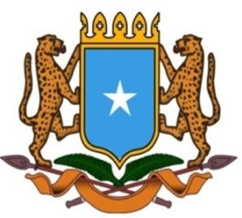 | جمهورية الصوما ل الفيدرالية  البعثة الدائمة لجمهورية الصومال بمكتب الأمم المتحدة بجنيف وبالوكالات المتخصصة بسويسرا

Permanent Mission of the Federal Republic of Somalia to the United Nations Office at Geneva and other International Organizations in Switzerland

Check Against Delivery
Statement by the Delegations of Somalia,
H.E. Ms. Ebyan Mahamed Salah, Ambassador and Permanent Representative
at the Review of Mali, during the 43rd Session of the UPR Working Group on Monday, 08 May, 2023 from 02:30 PM to 06:00PM, in the Room XX of the Palais des Nations in Geneva, Speaker Number 102, Time: 1 minute and 00 seconds.
Thank you Mr. President,

Somalia warmly welcomes the distinguished delegation of the United Arab Emirates to this UPR session and appreciates its presentation of a comprehensive national report as well as its genuine engagement with the HRC today.

Somalia commends the efforts made by the government to implement the recommendations received since last review and the tremendous progress achieved in the field of human rights.
As a constructive contribution to this Universal Periodic Review, my delegation would like to share the following recommendations:
- Take all necessary measures to ensure the effective implementation of the voluntary commitment made by the government to achieve Goal 5 of SDG (Sustainable development goal), by ensuring a quota of 30 per cent in the middle and senior management positions for women by 2025.

- To develop measures to increase quality education and educational access in rural areas to lessen the proficiency gap between rural and urban areas.

Somalia wishes UAE delegation every success in this review.

I Thank you Mr. President.

