Jamhuuriyadda Federaalka Soomaaliya  Ergada Joogtada Soomaliyeed ee Qaramada Midoobey ee Geneva | 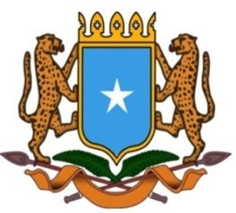 | جمهورية الصوما ل الفيدرالية  البعثة الدائمة لجمهورية الصومال بمكتب الأمم المتحدة بجنيف وبالوكالات المتخصصة بسويسرا

Permanent Mission of the Federal Republic of Somalia to the United Nations Office at Geneva and other International Organizations in Switzerland

Check Against Delivery
Statement by the Delegations of Somalia,
H.E. Ms. Ebyan Mahamed Salah, Ambassador and Permanent Representative
at the Review of Burundi, during the 43rd Session of the UPR Working Group on Thursday, 04 May, 2023 from 09:00 to 12:30 , in the Room XX of the Palais des Nations in Geneva, Speaker Number 62, Time: 1 minute and 10 seconds.
Thank you Mr. President,

Somalia warmly welcomes the distinguished delegation of the Republic of Burundi to this fourth cycle of the UPR working group and thanks them for their comprehensive national report, which has been prepared with greatest care and a spirit of inclusiveness and dialogue among all actors involved in the human rights issues.

This should demonstrate the government's determination to promote and protect the human rights principles and values with due respect to the principles of objectivity, impartiality and non-selectivity.

Somalia appreciates the several legal and institutional frameworks put in place by Burundi in order to promote economic, political and social development.
Somalia congratulates Burundi for the great progress achieved in the area of human rights since last review and recommends the following :

1. Continue implementing National Women’s Economic Empowerment Programme 2019–2027, and enhance the financial capacity of the Women’s Investment and Development Bank,
2. Consider ratifying the International Convention on the Protection of the Rights of All Migrant Workers and Members of Their Families.

Somalia wishes to the distinguished delegation of Burundi a successful outcome in this review. I

Thank you Mr. President.

