Jamhuuriyadda Federaalka Soomaaliya  Ergada Joogtada Soomaliyeed ee Qaramada Midoobey ee Geneva | 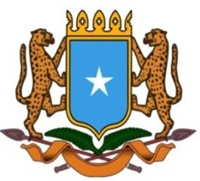 | جمهورية الصوما ل الفيدرالية  البعثة الدائمة لجمهورية الصومال بمكتب الأمم المتحدة بجنيف وبالوكالات المتخصصة بسويسرا

Permanent Mission of the Federal Republic of Somalia to the United Nations Office at Geneva and other International Organizations in Switzerland

Check Against Delivery
Statement by the Delegations of Somalia,
H.E. Ms. Ebyan Mahamed Salah, Ambassador and Permanent Representative
at the Review of Mali, during the 43rd Session of the UPR Working Group on Wednesday, 03 May, 2023 from 09:00 to 12:30 , in the Room XX of the Palais des Nations in Geneva, Speaker Number 84, Time: 1 minute and 05 seconds.
Thank you Mr. President,

Somalia warmly welcomes the distinguished delegation of the Republic of Botswana to this fourth cycle of the UPR working group and thanks them for their comprehensive national report.

Somalia welcomes the Botswana’s ratification to the United Nations Convention on the Rights of Persons with Disabilities (CRPD) in July 2021 and the legislative measures taken to align the Convention into the national legislation.
Somalia recommends the following :

- Adopt a strong domestic law, policy, and strategy frameworks that are in conformity with the international standard with a view to better protect and promote the rights of refugees and Asylum seekers.
2. Strengthen its national mechanism to protect migrants and asylum seekers from sexual exploitation and trafficking, by collaborating with the relevant institutions at regional, and international level.
Somalia wishes to the distinguished delegation of Botswana a successful outcome in this review.

I Thank you Mr. President.

