Jamhuuriyadda Federaalka Soomaaliya  Ergada Joogtada Soomaliyeed ee Qaramada Midoobey ee Geneva | 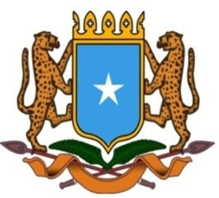 | جمهورية الصوما ل الفيدرالية  البعثة الدائمة لجمهورية الصومال بمكتب الأمم المتحدة بجنيف وبالوكالات المتخصصة بسويسرا

Permanent Mission of the Federal Republic of Somalia to the United Nations Office at Geneva and other International Organizations in Switzerland

Check Against Delivery
Statement by the Delegations of Somalia,
H.E. Ms. Ebyan Mahamed Salah, Ambassador and Permanent Representative
at the Review of Mali, during the 43rd Session of the UPR Working Group on Tuesday, 02 May, 2023 from 02:30 PM to 06:00PM, in the Room XX of the Palais des Nations in Geneva, Speaker Number 28, Time: 1 minute and 10 seconds.
Thank you Mr. President,

Somalia warmly welcomes the distinguished delegation of the Republic of Mali to this UPR session and thanks them for the comprehensive national report and the update provided today.

As a constructive contribution to this Universal Periodic Review, my delegation would like to share the following recommendations:

1. Redouble efforts to combat poverty and employment in particular on youth, persons with disabilities and women by allocation the necessary resources to the national institution responsible for the implementation of the national employment policy,
2. To continue strengthening its collaboration with the Human Rights Mechanism at regional and international level, including the Office of the High Commissioner for Human Rights as well as this august Council,
3. To step up efforts aimed at achieving national reconciliation for a lasting peace, economic development and democratic institutions for the benefit of the people of Mali.
Somalia would like to conclude by wishing to the distinguished delegation of Mali a successful outcome in this review.

I Thank you Mr. President.

