Jamhuuriyadda Federaalka Soomaaliya  Ergada Joogtada Soomaliyeed ee Qaramada Midoobey ee Geneva | 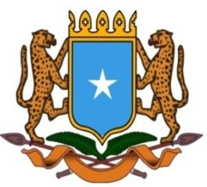 | جمهورية الصوما ل الفيدرالية  البعثة الدائمة لجمهورية الصومال بمكتب الأمم المتحدة بجنيف وبالوكالات المتخصصة بسويسرا

Permanent Mission of the Federal Republic of Somalia to the United Nations Office at Geneva and other International Organizations in Switzerland

Check Against Delivery
Statement by the Delegations of Somalia,
H.E. Ms. Ebyan Mahamed Salah, Ambassador and Permanent Representative
at the Review of France, during the 43rd Session of the UPR Working Group on Monday, 01 May, 2023 from 9:00AM to 12:30PM, in the Room XX of the Palais des Nations in Geneva, Speaker Number 11, Time: 00 minute and 55 seconds.)
Thank you Mr. President,

Somalia warmly welcomes the distinguished delegation of France for the comprehensive national report and the update provided today.

Somalia commends the efforts made by the government to implement the recommendations accepted during its last review, and the steps taken to further promote and protect human rights across the country.

Somalia offers the following recommendations:

1. To ratify Treaty on the Prohibition of Nuclear Weapons (TPNW)

2. To adopt necessary measures to effectively promote the rights of asylum seekers and migrants by guaranteeing access to basic human needs,

3. To take additional measures to combat discrimination in the field of education by guaranteeing access to all levels of education to the vulnerable groups, including persons with disabilities.

Somalia would like to conclude by wishing the distinguished delegation of France a successful outcome in this review.

I Thank you Mr. President.

