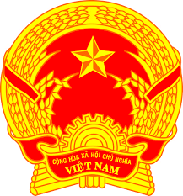
Statement of the Socialist Republic of Viet Nam
43rd Session of the UPR Working Group
Review of Serbia
(Geneva, 10 May 2023)

Time: 1 minute and 15 seconds
Mister President,
Viet Nam welcomes the delegation of Serbia and thanks them for the national UPR report.
We welcome a number of measures taken by Serbia to carry out recommendations since the adoption of its third UPR report, including the adoption of amendments to the Law on the Prohibition of Discrimination in 2021, introducing improvements to the anti-discrimination framework.
In a spirit of constructive dialogue, we wish to recommend to Serbia:
First, improve the normative framework for the promotion and protection of children’s rights.
Second, continue its efforts to combat domestic violence.
In conclusion, Viet Nam wishes Serbia every success with this UPR cycle.
Thank you, Mister President./.

