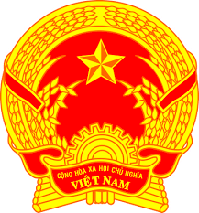
Statement of the Socialist Republic of Viet Nam
43rd Session of the UPR Working Group
Review of Liechtenstein
(Geneva, 09 May 2023)

Time: 1 minute and 35 seconds
Mister President,
Viet Nam welcomes the Delegation of Liechtenstein and thanks them for the comprehensive presentation of the national UPR report.
Viet Nam commends Liechtenstein for the implementation of the recommnedations from the last UPR review and the progress made in the review period with the high level of human rights promotion and protection both at the national level and at the international level. Especially we welcome Liechtenstein’s contributions to the strengthening of global sustainable development and particularly to the reduction of global poverty through the active engagement of its International Humanitarian Cooperation and Development.
In a spirit of constructive dialogue for further improvements, Viet Nam makes two recommendations to Liechtenstein:
First, take steps to develop and adopt a comprehensive legal framework to prevent and protect children from all forms of violence, including within the family, online and at schools.
Second, take appropriate measures to increase the representation of women in decision making positions.
In conclusion, Viet Nam wishes Liechtenstein every success with this UPR cycle.
Thank you, Mister President./.

