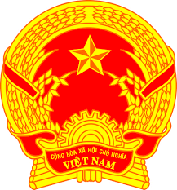
Statement of the Socialist Republic of Viet Nam
43rd Session of the UPR Working Group
Review of Israel
(Geneva, 9th May 2023)

Delivered by Mr. NGUYEN Khanh Toan, First Secretary

Mister President,
Viet Nam welcomes and thanks the delegation of Israel for the comprehensive presentation of the national UPR report.
We welcome Israel’s achievements in the review period, including the engagement and leadership of Israel at various international human rights mechanisms and in ensuring the right to health, particularly the access to essential medical treatments and vaccines and protecting the most vulnerable during the COVID-19 pandemic.
In a spirit of constructive dialogue, Viet Nam recommends the following:
First, step up efforts to eliminate all forms of discrimination.
Second, continue efforts to prevent and eliminate violence against women and increase inclusion of women in decision making positions.
In conclusion, Viet Nam wishes Israel every success with this UPR cycle.
Thank you, Mister President./.

