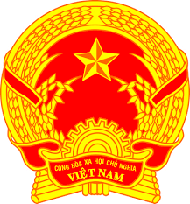
Statement of the Socialist Republic of Viet Nam
43nd Session of the UPR Working Group
Review of the United Arab Emirates
(Geneva, 08 May 2023)

Delivered by H.E. Ms. LE Thi Tuyet Mai,
Ambassador, Permanent Representative of Viet Nam to the UNOG

Mister President,
Viet Nam welcomes the United Arab Emirates delegation and thanks them for presenting their national report.
We commend the UAE's progress in strengthening its legal framework as well as the implementation of numerous national policies and strategies that seek to promote and protect human rights, including the national strategy for the empowerment and advancement of women, the national strategy to empower persons with disabilities.
In the spirit of meaningful dialogue, Viet Nam wishes to make the following recommendations:
- First, develop a national plan for public education and awareness on human rights.
- Second, develop a national plan to educate and raise awareness targeting the public servants.
We wish the delegation of the UAE a very successful UPR process.
Thank you, Mister President./.

