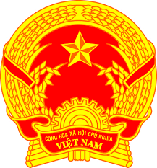
Statement of the Socialist Republic of Viet Nam
43rd Session of the UPR Working Group
Review of Montenegro
(Geneva, 08 May 2023)

Time: 1 minute and 25 seconds
Mister President,
Viet Nam welcomes the delegation of Montenegro and thanks them for the national UPR report.
We commend Montenegro for the substantial progress in strengthening its institutional and legislative framework in the field of promotion and protection of human rights and fundamental freedoms since the adoption of its third UPR report. We welcome Montenegro’s adoption of its National Employment Strategy for the period of 2021-2025 to achieve stable and sustainable employment growth on the basis of equal access of the labour market, dignified work, further development of knowledge and skills, and greater social inclusion.
In a spirit of constructive dialogue, Viet Nam would like to make the following recommendations to Montenegro:
First, continue its efforts to improve the promotion and protection of the rights of vulnerable groups, particularly women, children and persons with disabilities.
Second, strengthen measures for reducing poverty and develop an evaluation mechanism to assess the impact of measures taken.
In conclusion, Viet Nam wishes Montenegro every success with this UPR cycle.
Thank you, Mister President./.

