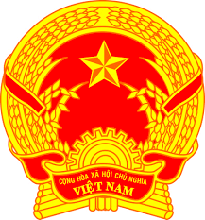
Statement of the Socialist Republic of Viet Nam
43rd Session of the UPR Working Group
Review of Barbados
(Geneva, 05 May 2023)

Time: 1 minute and 30 seconds
Mister President,
Viet Nam welcomes and thanks the delegation of Barbados for its national UPR report.
We welcome the significant steps made by Barbados to include more female representation in decision-making positions, primarily with the election of the country’s first female Prime Minister. We also commend Barbados for its efforts to improve the enjoyment of the right to education by its people.
In a spirit of constructive dialogue, Viet Nam would like to make the following recommendations to Barbados:
First, continue its efforts to combat all forms of violence against women.
Second, continue its efforts to ensure the right to an adequate standard of living for all its citizens.
In conclusion, Viet Nam wishes Barbados every success with this UPR cycle.
Thank you, Mister President./.

