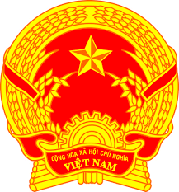
Statement of the Socialist Republic of Viet Nam
43rd Session of the UPR Working Group
Review of Burundi
(Geneva, 4th May 2023)

Mister President,
Viet Nam welcomes and thanks the delegation of Burundi for the comprehensive presentation of the national UPR report.
We welcome Burundi's achievements in the review period, particularly through the implementation of effective measures to strengthen social cohesion and security and consolidate social and economic development programs.
In a spirit of constructive dialogue, Viet Nam makes two recommendations to Burundi:
First, continue efforts to strengthen the healthcare system, particularly maternal and child healthcare system.
Second, continue its commendable efforts to improve the environment and ensure the well-being of the people.
In conclusion, Viet Nam wishes Burundi every success with this UPR cycle.
Thank you, Mister President./.

