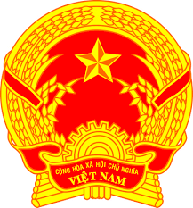
Statement of the Socialist Republic of Viet Nam
43rd Session of the UPR Working Group
Review of Bahamas
(Geneva, 03 May 2023)

Time: 1 minute 25 seconds
Mister President,
Viet Nam welcomes and thanks the delegation of The Bahamas for its national UPR report.
We commend The Bahamas for the progress made in its National Development Plan processes with outcomes being achieved in the areas of a modern, open and accountable government, public institutions and the respect for the rule of law. We take note of the commitment of The Bahamas to realizing the 2030 Agenda for Sustainable Development.
In a spirit of constructive dialogue, Viet Nam has two recommendations to The Bahamas:
First, continue its efforts to ensure the effective prohibition of discrimination on the basis of gender through appropriate enforcement mechanisms and sanctions.
Second, continue its efforts to promote and protect the rights of children, including taking measures to protect children from all forms of violence.
Viet Nam wishes The Bahamas a successful review.
Thank you, Mister President./.

