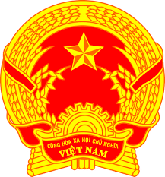
Statement of the Socialist Republic of Viet Nam
43nd Session of the UPR Working Group
Review of Botswana
(Geneva, 03 May 2023)

Delivered by H.E. Ms. LE Thi Tuyet Mai,
Ambassador, Permanent Representative of Viet Nam to the UNOG

Mister Vice-President,
Viet Nam welcomes and thanks the delegation of Botswana for the presentation of its national report.
We commend Botswana's efforts in promoting and protecting human rights, particularly in the areas of poverty reduction and combat against HIV/AIDS. We also welcome Botswana's accession to the United Nations Convention on the Rights of Persons with Disabilities, the approval of the Revised Disability Policy and the drafting of the Disability Bill.
In a spirit of constructive dialogue, Viet Nam would like to make the following recommendations to Botswana:
- One, strengthen national programs for the economic empowerment of women, youth, and other vulnerable members of society.
- Two, continue efforts to provide quality education for all, especially for girls and persons with disabilities.
We wish the delegation of Botswana a very successful UPR process.
Thank you, Mister Vice-President./.

