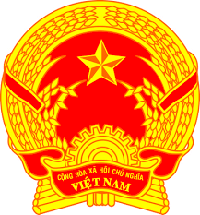
Statement of the Socialist Republic of Viet Nam
43nd Session of the UPR Working Group
Review of France
(Geneva, 01 May 2023)

Delivered by H.E. Ms. LE Thi Tuyet Mai,
Ambassador, Permanent Representative of Viet Nam to the UNOG

Mister President,
Viet Nam welcomes and thanks the delegation of France for their comprehensive presentation of the national report. We commend France's significant progress in promoting and protecting human rights since the last review, particularly in the face of COVID-19 pandemic and climate change.
Viet Nam would like to make two recommendations to France:
- One, adopt a strategy for implementing the Convention on the Rights of Persons with Disabilities, with particular attention to vocational training and employment.
- Two, strengthen efforts to improve access to quality healthcare for all, with a focus on vulnerable populations.
Viet Nam wishes France every success with this UPR cycle.
Thank you, Mister President./.

