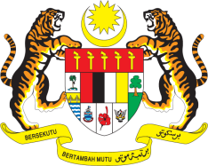

STATEMENT BY MALAYSIA
REVIEW OF SERBIA
43RD SESSION OF THE UPR WORKING GROUP
1 – 12 MAY 2023

Malaysia thanks Serbia for the presentation of their national report.

- Malaysia commends Serbia for the improvements that have been made in its legislative and institutional framework towards the advancement of human rights. The implementation of national policies and strategies to fight against hate crimes and hate speech, domestic violence, human trafficking, and corruption exemplifies this commitment, effort and progress.

- In the spirit of constructive engagement, Malaysia recommends the following:

3.1 Increase efforts to promote tolerance for persons belonging to ethnic, racial, religious and other minorities and address all manifestations of discrimination more effectively;

3.2 Continue to uphold the rights of women and girls and overcome the gender gap through effective implementation of its Law on Gender Equality and Strategy for Gender Equality; and

3.3 Accelerate efforts to amend the Family Law to ensure the abolition of child marriage provide effective protection of victims of gender-based violence, and to align the definition of rape with international standards in accordance with the Istanbul Convention.

- We wish Serbia a successful review.

Thank you.

10 MAY 2023
GENEVA

