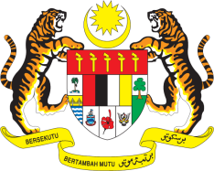

STATEMENT BY MALAYSIA
REVIEW OF LIECHTENSTEIN
43RD SESSION OF THE UPR WORKING GROUP
1 – 12 MAY 2023

Malaysia thanks Liechtenstein for the presentation of their national report.

- Malaysia commends Liechtenstein’s commitment towards advancing the rights of its people including the significant progress it has made in implementing several accepted recommendations from the previous UPR. We also welcome the signing of the Convention on the Rights of Persons with Disabilities and encourage Liechtenstein to step up efforts towards its ratification.

- However, we believe there is still more to be done to further reinforce the government’s responses against manifestations of discrimination including racial and religious hate crimes.

- In the spirit of constructive engagement, Malaysia recommends the following:

4.1 Step up efforts to ensure effective response to matters related to anti-Muslim attacks, Islamophobia, racism, racial discrimination, xenophobia and other related intolerance directed at ethnic and religious minorities;

4.2 Take further measures to promote the representation of women in leadership and decision-making positions; and

4.3 Increase efforts to ensure that persons with disabilities have sufficient access to employment, information, health services, the judicial system, transport, and communications.

- We wish Liechtenstein a successful review.

Thank you.

9 MAY 2023
GENEVA

