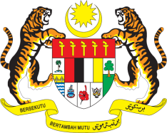

STATEMENT BY MALAYSIA
REVIEW OF ISRAEL
43RD SESSION OF THE UPR WORKING GROUP
1 – 12 MAY 2023

Mr. President,

Malaysia affirms its unwavering support to the Palestinian cause and strongly recommends the Occupying Power to:

- End the illegal occupation of all occupied Palestinian and Arab Territories, including East Jerusalem and end the destruction of Palestinian private and public property;

- Stop and reverse all colonial-apartheid policies and practices that contribute to the fragmentation of the Palestinian people, deny their right to self-determination and permanent sovereignty over their lands and other natural resources;

- Respect the rights of Palestinians to freedom of movement in the Occupied Palestinian Territory, including access to religious sites such as the Al-Aqsa mosque and through the lifting of the blockade on the Gaza Strip; and

- Fully cooperate with UN bodies and human rights mechanisms and other international judiciary, including by allowing them unfettered access to Israel and the Occupied Palestinian Territory to carry out investigations, and heeding their recommendations to swiftly improve the human rights and humanitarian situation.

2. The Occupying Power’s blatant disregard of the various UN resolutions and widespread impunity must be addressed by this Council.

Thank you.

9 MAY 2023
GENEVA

