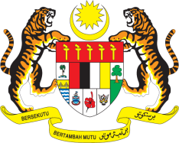

STATEMENT BY MALAYSIA
REVIEW OF THE UNITED ARAB EMIRATES
43RD SESSION OF THE UPR WORKING GROUP
1 – 12 MAY 2023

Mr. President,

Malaysia thanks the UAE for the presentation of their national report.

- Malaysia commends the UAE for its commitment, efforts and progress in the field of human rights.

- In the spirit of constructive engagement, Malaysia recommends the following:

3.1 Strengthen the implementation of the national strategy for women’s empowerment for the year 2022–2027 to bridge gender gap and ensure gender equality, increase women’s involvement in all segments of society, promote women leaders and tackle discrimination against women;

3.2 Continue efforts to protect the rights of workers including foreign domestic workers, from discrimination and sexual harassment by strengthening its labour laws and its enforcement as well as improving working conditions; and

3.3 Accelerate efforts to combat climate change and fulfil its commitment to reduce carbon emissions by 2050, including through utilising low-carbon technologies and investing in renewable energy.

- We wish the UAE a successful review.

Thank you.

8 MAY 2023
GENEVA

