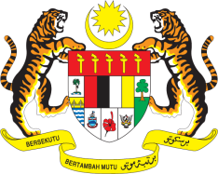

STATEMENT BY MALAYSIA
REVIEW OF MONTENGERO
43RD SESSION OF THE UPR WORKING GROUP
1 – 12 MAY 2023

Malaysia thanks Montenegro for the presentation of their national report.

2. Malaysia commends Montenegro’s efforts to improve the human rights situation in the country including by adopting a whole-of-nation-approach in the implementation of recommendations. We are also encouraged that the government has taken concrete steps to tackle domestic violence as per our recommendations made in the previous UPR cycle.

3. In the spirit of constructive engagement, Malaysia recommends the following:

3.1 Ensure that national policies that have been designed to provide education and training to public authorities, strengthen capacities for the implementation of legislation that protect against abuses of human rights including discrimination;

3.2 Ensure that the establishment of the Operational Teams on combating domestic violence, violence against women and human trafficking are complementary to on-going national efforts to combat these crimes;

3.2 Enhance measures in fighting poverty and reduce social exclusion of vulnerable groups of the population, including women, children and national minorities.

4. We wish Montenegro a successful review.

Thank you.

8 MAY 2023
GENEVA

