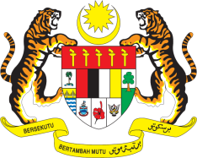

STATEMENT BY MALAYSIA
REVIEW OF BARBADOS
43RD SESSION OF THE UPR WORKING GROUP
1 – 12 MAY 2023

Malaysia thanks Barbados for the presentation of its national report.

- Malaysia congratulates Barbados for the election of its first female Prime Minister, and the country’s transition to a Parliamentary Republic in November 2021. We welcome various efforts undertaken by Barbados to promote economic, social and cultural rights including measures to ensure transparent, efficient and accountable delivery of public services in its national development strategy.

- In the spirit of constructive engagement, Malaysia recommends the following:

3.1 Strengthen the design and implementation of public health policy to create health-promoting environment and to reduce the risk factors for non-communicable diseases, especially among children;

3.2 Accelerate efforts to promote women’s rights and achieve gender equality by providing women with equal opportunities and access to the labour market, as well as equal pay for the same labour services as men; and

3.3 Consider to implement sexual and reproductive health legislation through the development of integral policies.

- We wish Barbados a successful review.

Thank you.

5 MAY 2023
GENEVA

