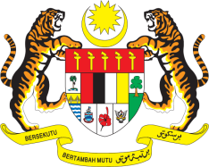

STATEMENT BY MALAYSIA
REVIEW OF LUXEMBOURG
43RD SESSION OF THE UPR WORKING GROUP
1 – 12 MAY 2023

Malaysia thanks Luxembourg for the presentation of its national report.

- Malaysia commends Luxembourg for its commitment to ensure the indivisibility of human rights. We welcome its progress and achievements in the field of human rights though various policies and programmes at the national level, as well as its contribution in the global human rights promotion through technical assistance, specific support and projects in partner countries.

- In the spirit of constructive engagement, Malaysia recommends the following:

3.1 Strengthen legal framework and national policies to combat racial discrimination, xenophobia, and related intolerance including online hate speech and Islamophobia;

3.2 Continues to provide technical assistance through its development cooperation programme to support the promotion of human rights, especially those related to economic, social and cultural rights; and

3.3 Step up efforts to combat poverty and inequality, and renew the commitment towards ending child poverty, including through the development of a national plan of action.

- We wish Luxembourg a successful review.

Thank you.

4 MAY 2023
GENEVA

