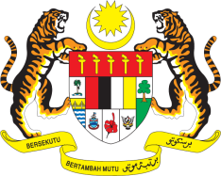

STATEMENT BY MALAYSIA
REVIEW OF BURUNDI
43RD SESSION OF THE UPR WORKING GROUP
1 – 12 MAY 2023

Malaysia thanks Burundi for the presentation of its national report.

- Malaysia commends Burundi on its strong commitment to promote and protect human rights through institutional and legislative reforms. We welcome various measures taken by the Government to address all forms of gender-based violence. We further welcome efforts to prevent trafficking in persons and to punish perpetrators. Burundi’s commitment to provide free basic education and ensure continuous improvement of health of its population are commendable.

- In the spirit of constructive engagement, Malaysia recommends the following:

3.1 Strengthen actions to tackle drivers of food insecurity, to end hunger and address child malnutrition including in rural areas;

3.2 Step up efforts to ensure the access to safe drinking water and basic sanitation, by addressing the main barriers, investing in quality sanitation infrastructures and increasing water points in public facilities including schools and health centres; and

3.3 Continue efforts to address challenges in the field of education and to adopt positive measures to tackle the issues of high school dropout rates among young people and low rates of secondary school completion among girls.

- We wish Burundi a successful review.

Thank you.

4 MAY 2023
GENEVA

