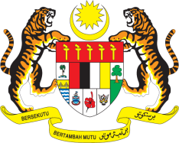

STATEMENT BY MALAYSIA
REVIEW OF THE BAHAMAS
43RD SESSION OF THE UPR WORKING GROUP
1 – 12 MAY 2023

Malaysia welcomes the delegation of the Bahamas and thanks them for the presentation of their national report.

- Malaysia commends the Government of the Bahamas for its commitment to ensure the enjoyment of human rights and fundamental freedoms for its people. We recognise the challenges that the Bahamas faces as a small island developing state including in the context of negative consequences of climate change and natural disasters. In this regard, we call on the international community to continue providing support to the Bahamas to facilitate the country in the realisation of human rights for all, through capacity-building and technical assistance programmes.

- In the spirit of constructive engagement, Malaysia recommends the following:

3.1 Step up efforts in establishing a national human rights institution in line with the Paris Principles; and

3.2 Continue efforts to strengthen gender equality and eliminate discrimination and stigmatisation faced by women and girls.

- We wish the Bahamas a successful review.

Thank you.

2 MAY 2023
GENEVA

