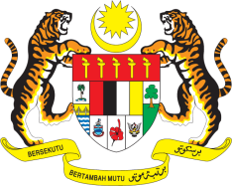

STATEMENT BY MALAYSIA
REVIEW OF BOTSWANA
43RD SESSION OF THE UPR WORKING GROUP
1 – 12 MAY 2023

Malaysia thanks Botswana for the presentation of its national report.

- Malaysia takes note of several reforms and policy implementations aimed at promoting sustainable industries and trade, improving social protection, providing economic opportunities to vulnerable populations, and empowering youth economically.

- In the spirit of constructive engagement, Malaysia recommends the following:

3.1 Effectively implement its National Policy on Gender and Development through a comprehensive strategy to ensure equal access to the socio-economic, cultural and political opportunities for men and women;

3.2 Step up efforts to eradicate poverty by ensuring those living in poverty have sufficient access to social assistance; and

3.3 Strengthen the access to family planning information and services, including the access to quality, affordable and safe modern contraceptives through capacity building for healthcare workers on the integration of family planning services at all service delivery points.

- We wish Botswana a successful review.

Thank you.

3 MAY 2023
GENEVA

