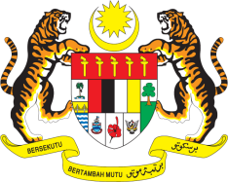

STATEMENT BY MALAYSIA
REVIEW OF MALI
43RD SESSION OF THE UPR WORKING GROUP
1 – 12 MAY 2023

Malaysia commends Mali’s commitment to human rights and its efforts to harmonise national legislations with international obligations. We welcome Mali’s efforts to prohibit the use of children in armed conflict.

- However, Malaysia is concerned that a high number of schools in Mali remain closed due to lack of security, thus restricting Malian children’s right to education. We hope that the government would take all necessary measures to reopen schools and ensure the safety and security of children and school staff.

- In the spirit of constructive engagement, Malaysia recommends the following:

3.1 Continue its efforts in strengthening the capacities of State and non-State actors in the field of human rights by providing comprehensive human rights education and training, with the support of relevant UN bodies such as MINUSMA;

3.2 Adopt concrete measures to improve access to education for all and prevent early school dropout, in particular girls and those in rural areas; and

3.3 Step up efforts to address cases of chronic malnutrition among children, as well as regularly monitor and assess the effectiveness of policies and programmes to tackle the issue.

- We wish Mali a successful review.

Thank you.

2 MAY 2023
GENEVA

