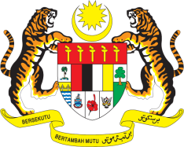

STATEMENT BY MALAYSIA
REVIEW OF ROMANIA
43RD SESSION OF THE UPR WORKING GROUP
1 – 12 MAY 2023

Malaysia thanks Romania for its report.

- Malaysia welcomes Romania’s commitment to implement the UPR recommendations by adopting several national strategies in key areas, including the independence of the judiciary, anti-corruption, as well as equality and non-discrimination. We encourage Romania to continue its efforts to protect vulnerable groups such as women, children and persons with disabilities.

- In the spirit of constructive engagement, Malaysia recommends the following:

3.1 Accelerate the reform of its education system to provide equitable, inclusive and quality education, including for children in vulnerable situations;

3.2 Promote right to health by improving access to health services for all, reducing infant and maternal mortality, and addressing teenage pregnancies; and

3.3 Promote, instil and integrate human rights principles in the national public service, including in the design and implementation of digital technologies in public services.

- We wish Romania a successful review.

Thank you.

2 MAY 2023
GENEVA

