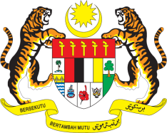

STATEMENT BY MALAYSIA
REVIEW OF TONGA
43RD SESSION OF THE UPR WORKING GROUP
1 – 12 MAY 2023

Malaysia welcomes the delegation of Tonga and thanks them for the presentation of their national report.

- Malaysia commends Tonga for its efforts to promote and protect human rights of its people. Despite the major challenges posed by the COVID-19 pandemic and the devastating tsunami in the country, we are encouraged by the commitment shown by Tonga to continue providing human rights protections for all, including vulnerable groups. Notably, we commend the improvement of its social welfare assistance that benefits older persons and persons with disabilities in Tonga.

- We also hope that the international community and the OHCHR will continue to provide the necessary support for the Voluntary Technical Assistance Trust Fund to allow for the participation of Tongan nationals in the work of the HRC.

- In the spirit of constructive engagement, Malaysia recommends the following:

4.1 Continue efforts to ratify the Convention on the Elimination of All Forms of Discrimination against Women (CEDAW);

4.2 Establish a national human rights institution in line with the Paris Principles; and

4.3 Promote right to health by taking steps to strengthen its health-care system, especially in dealing with chronic cases and non-communicable diseases, in particular in rural and remote areas.

- We wish Tonga a successful review.

Thank you.

1 MAY 2023
GENEVA

